**Mary Stuart**

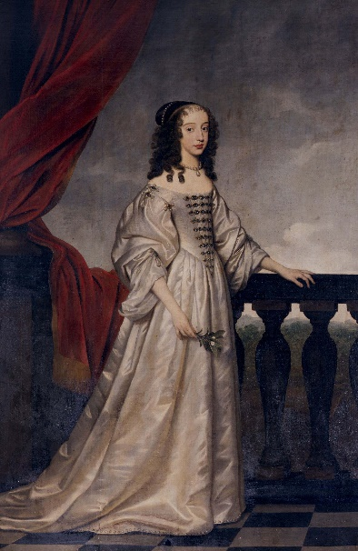

***Blog 1***

1558

I honestly can’t believe it… today is the day!! I’m getting married. I’m only sixteen, so it might seem to you as too early to become a wife. Wait until you hear how old, or should I say young, my soon to be husband is. He is 14 years old. I will enlighten you with a few details; his name is Francis and he’s the Dauphin (Crown Prince) of France. That means that I’ll be queen of France after today, can you imagine? I mean, I’m already Queen of Scotland since I was only six days old, but still, I have lived in France since I was five years old. Currently, there are regents in my place reigning Scotland. If everything would have turned out differently, I would have been queen of England instead of France by now. I was to marry Prince Edward, the son of Henry VIII. That was decided in the treaty of Greenwich on the 1st of July, 1543. But a lot of confusing things happened after that on which I don’t want to elaborate right now. I was sent to France for my own safety and was promised a marriage with Francis. So that is what is going to happen today. My life isn’t uneventful up to now. I hope things settle down once we’re married and I hope we’ll learn to love each other. His looks are not an issue, since he is absolutely gorgeous. I’m a lucky girl, I think many girls my age will be rather jealous of me today.

***Blog 2***

1560

My heart is completely shattered. I don’t even know how I can find the strength to write this down, but I need to do something or I’ll go crazy. Francis died today. He had been lying in bed for a week due to an ear infection and today his body gave up. Even though I was only married to him for a year and a half, we became really fond of each other in that short period of time. We could have been happy, I know for sure. If only is body would have been less weak, he was often ill. I’m grateful that I went over to the infirmary today to talk to him for a while and that we had a peaceful and loving conversation. Apart from the fact that I’m heartbroken about Francis’ death, I’m also worried about my future. I have been queen of France and a wife for 17 months and now it’s over. I will have to go back to Scotland.

**Source: Zweig, S., Paul, E., & Paul, C. (2011). Mary Stuart. London, United Kingdom: HarperCollins Publishers.**

**Henry Tudor VIII**

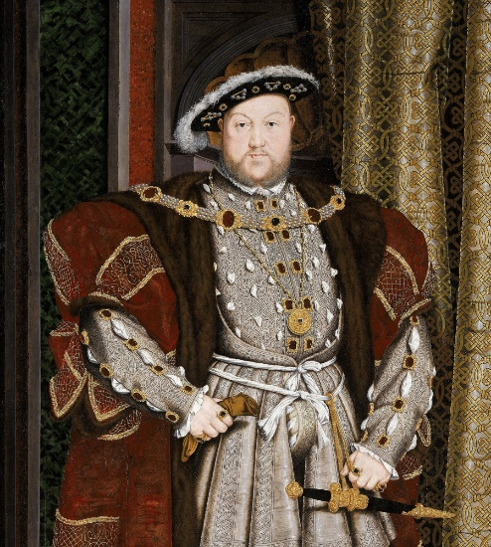 ***Blog 1***

1533

I can’t go on like this any longer. My wife, Catherine, has failed to give me an heir tot he throne and now I am running out of patience. If I don’t have a son, the Tudor dynasty will ceise to excist and I can’t let that happen. So far I’ve come up with three solutions. I could try to legitimise my bastard son, Henry FitzRoy, I could try to get my daughter Mary to marry as soon as possible and have her produce an heir, my grandson or I could try to annul my marriage with Catherine in order to make my marriage with Anne Boleyn valid so that she is able to give me a son. The last option is the most desirable option since it would also rid me Catherine, so it would be killing two birds with one stone. However, I don’t yet know how to make this happen, since it is forbidden to end ones marriage according tot he Catholic Church of which I’m the *Fidei Defensor* (Defenser of the Faith). I need a plan to convince the Pope to grand me my annulment and I need it fast.

***Blog 2***

1534

Even though the Pope did not agree with my plan to divorce Catherine, I did find a way. Not only am I married to Anne Boleyn now, I also am Head of my own new church, the Church of England through the Acts of Supremacy. I had no other choice than to abolish the right of appeal to Rome through the Act in Restraint of Appeals. That means I should be happy now right, I got what I wanted. However, it seems like all this effort was for nothing, since Anne is failing to give me a male heir. I can’t believe it, I’ve given her everything, gave everything up for her and this is what I get in return. She’d better give me an heir quickly or else I might have to find another wife once more.

***Blog 3***

1536

Yesterday was not the best day I ever had. Not only did we burry Catherine my first wife, Anne also had miscarried a son. So, once again Anne was unable to provide me with heir I so much desire. She claims that it was due to the shock she received of my jousting accident last month. No matter what the reason Anne has proven to be a major dissappointment in many ways. I think at the moment my best option is to have a new marriage. A schuimtablet kandidate is a lady-in-wijting of the Queen, name Jane Seymour. Se is a lelie girl and I will move her into the new quarters so that I can have her close to me.

**Source: Weir, A. (2008b). Henry VIII: King and Court. Evansville, United States of America: Vintage.**

**Queen Victoria**

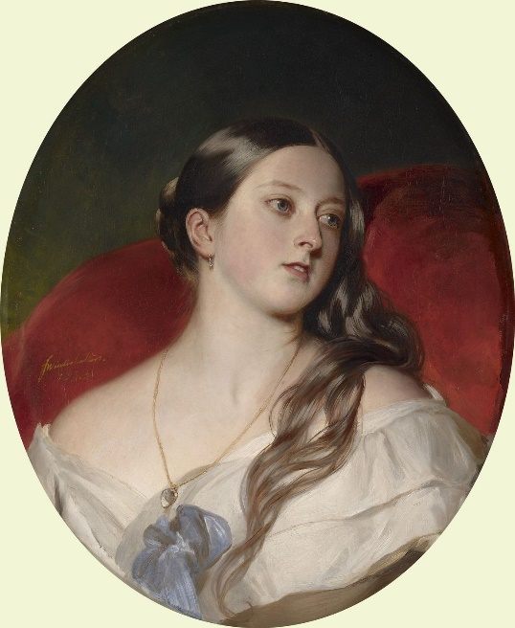

***Blog 1***

1836

I’m so excited! Last month, Leopold, my uncle, invited me and my mother to stay with them. Little did I know that he invited so that he could introduce me to his nephew, Prince Albert of Saxe-Coburg and Gotha. I know my uncle Wiliam IV, the current King, wants me to marry Prince Alexander of the Netherlands. However, I’ve met him a couple of months ago and I can honestly say that he was a very boring individual and that I have no interest whatsoever to marry him. Albert, on the other hand, has charmed me in a way I had not imagined in my sweetest dreams. He is absolutely gorgeous and on top of that very kind and gentle. I f I would have to marry someone, it would probably be him. But I realise that I’m too young to marry right now. Besides I have no clue if and when I will become Queen of Great Britain and how that will influence my future. Sometimes I dream of becoming Queen… the first thing I would do is make sure my mother and her dreadful lover, John Conroy are nowhere near me anymore. I’m so tired of the way they have treated me. Always keeping me inside and making me study, always having to sleep in my mother’s room instead of having some space of my own. That will all be over once I’m Queen and then I might marry my darling Prince Albert.

***Blog 2***

1862

Last year has been the worst year in my life. I can’t believe the worst thing has happened. The love of my life, Albert, is dead. He died last December of typhoid fever, leaving me widowed. I was already orphaned at the beginning of that year when my mother died. Despite the way she treated me when I was younger, we grew back together over the last period of her life. I realised how much she had loved me after she died and it broke my heart. At this moment I’m not sure if I’ll ever recover from my deep grief. I know will wear black for the rest of my life. I just can’t bare to go outside and to meet people, I want just to be left alone with my grief. Besides, I have gained a lot of weight after all these circumstances, since food is the only thing giving me comfort at the moment. Unfortunately, I know I can’t avoid my official government duties. I heard the public has given me the nickname ‘Widowof Windsor’ and it makes me feel sad, but they are right, aren’t they? Uncle Leopold has written me a letter advising me to make a public appearance again and even though it pains me to admit it, this might be a good idea. A good start is maybe visiting the gardens of the Royal Horticultural Society at Kensington and takeing a drive through London in an open carriage.

**Source: Hibbert, C. (2010). Queen Victoria: A Personal History. New York, United States of America: HarperCollins Publishers.**